Cro-Mags Upcoming Tour Includes
Opening for The Misfits
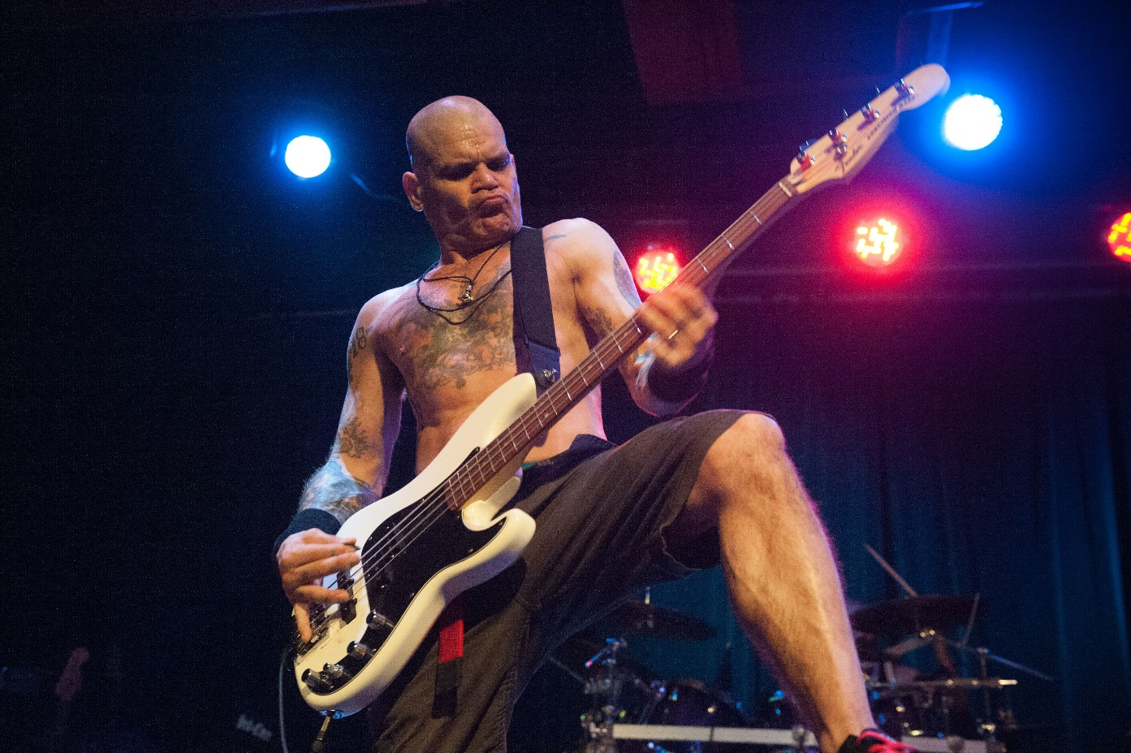

When Cro-Mags released their first new music in nearly 20 years on June 28th, fans rejoiced! Now the legendary hardcore punk band goes on tour, performing hits from their 30 + year catalogue, including “the best” from Best Wishes on its 30th anniversary. Tour highlights for both fans and Cro-Mags founder and front man, Harley Flanagan, include opening for The Misfits in select shows. “I’ve been a fan since I was a kid and from the start, Glenn and Jerry have been so great to me,” says Flanagan. “The Misfits are one of the first real punk bands and have a huge impact on what we know as punk, goth and metal today. It’s an absolute honor to play with them.”

In addition to The Misfits shows , Cro-Mags will perform throughout the US and in Europe. Current tour details below.
Raised in Europe and on New York’s gritty Lower East Side among iconic figures like Allen Ginsberg, Richard Hell, Debbie Harry, the Ramones, Andy Warhol and the Clash, Harley began his own musical career at age 11, performing at legendary hangouts like Max’s Kansas City (where he first met The Misfits) and CBGBs, as the drummer for the classic NYC Punk band, the Stimulators.
By the early 80s Harley founded the seminal Hardcore band, Cro-Mags, writing the majority of their music and channeling his powerful survival instinct into the blistering soundtrack and storyline for the 80’s and 90’s.
“Harley Flanagan’s incredible story is not just the history of New York hard core, of which he is a founding father, but a history of New York itself,” wrote dear friend and fan, Anthony Bourdain, for the cover of Harleys critically acclaimed memoire, Hard Core: Life of My Own.
Dave Grohl, among others have often said, there would be no Metallica, Green Day or Foo Fighters without the Cro-Mags. In March 2019, Harley was featured among America’s punk pioneers and the U.K.’s most notorious bands in PUNK, a four-part docuseries on EPIX from executive producer John Varvatos and punk music legend Iggy Pop.
In a world searching for authenticity- it doesn’t get any more real than Harley. His ever-growing popularity with audiences outside of the Punk and Hardcore world, is a testament to the ORIGINS of alternative music and lost histories from the visionaries who created it.

Cro-Mags Tour Dates with Misfits
Sept 7 – Denver, CO – Fiddler’s Green Amphitheater *
Sept 11 – Oakland, CA – Oracle Arena*
Sept 14 – Seattle, WA – White River Amphitheater *
Headlining European Tour w/ Red Death
Sept 27 – Essen, Germany – Turock
Sept 28 – Limburg, Belgium – Limburg Hardcore Fest
Sept 29 – London, United Kingdom – Underworld
Sept 30 – Paris, France – Gibus
Oct 01 – Stuttgart, Germany @ De Keller Klub
Oct 02 – Prague, Czech Rep @ Futurum
Oct 03 – Budapest, Hungary @ Hu Dürer Kert
Oct 04 – Graz, Austria @ Explosiv
Oct 05 – Leipzig, Germany @ Naumanns
Oct 06 – Berlin, Germany @ Musik & Frieden

Headlining - USA
Oct 17 – Las Vegas, NV – The Bunkhouse
Oct 18 – West Hollywood, CA – The Roxy
Oct 19 – Santa Ana, CA – La Santa

Harley Flanagan Online

Website
Facebook
Instagram

For more information on Harley Flanagan,
please contact:

Arkay Marketing & PR
Lucy Rendler-Kaplan: arkaylucy@gmail.com
847.347.2102

